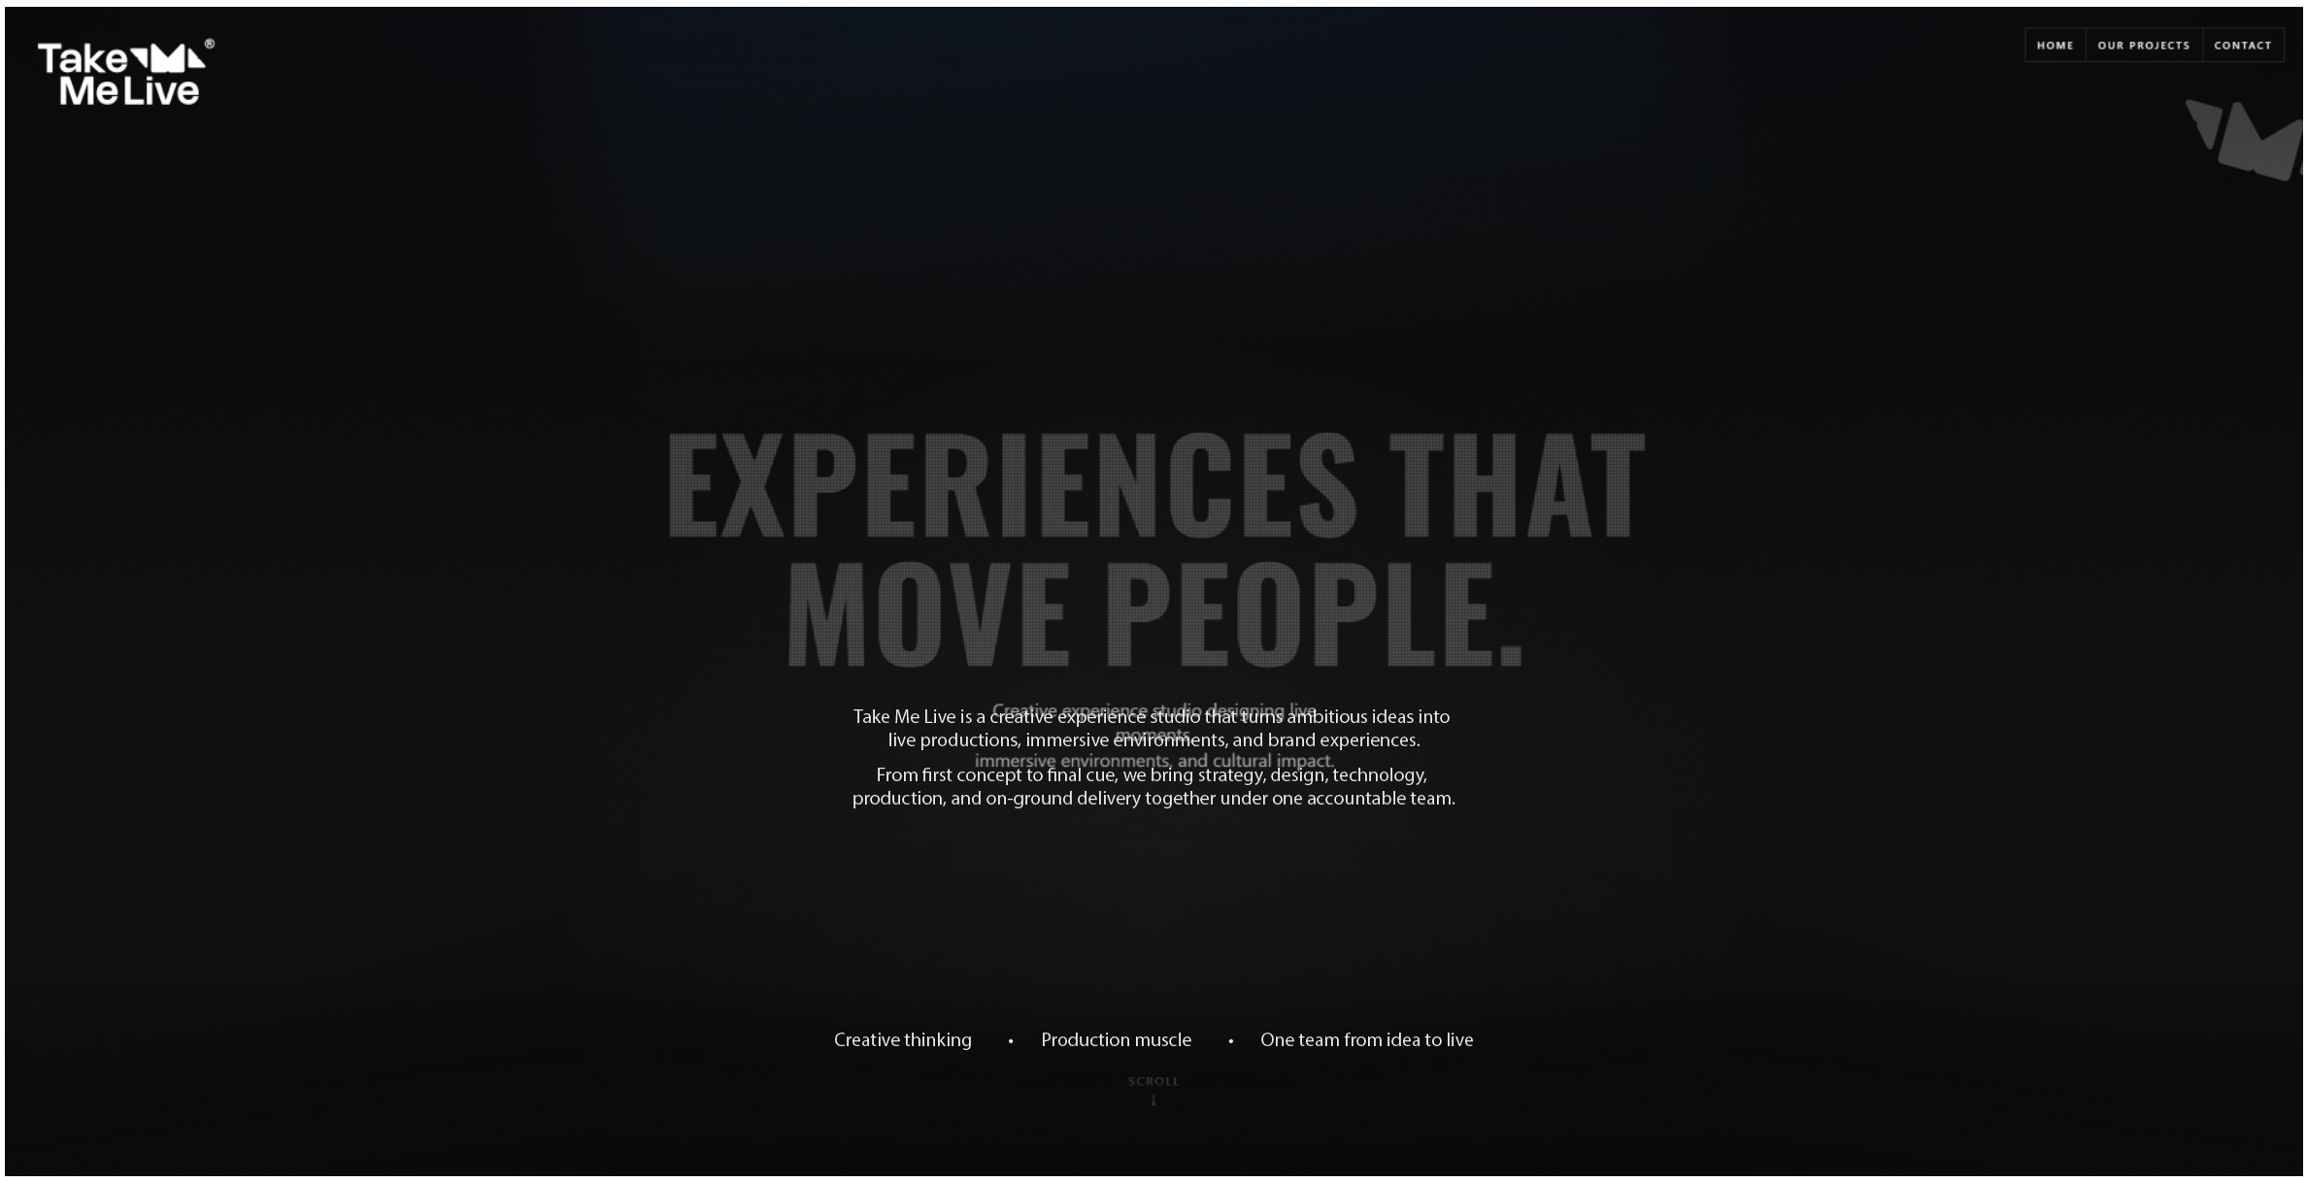

Supporting statement
Take Me Live is a creative experience studio that turns ambitious ideas into live productions, immersive environments, and brand experiences.
From first concept to final cue, we bring strategy, design, technology, production, and on-ground delivery together under one accountable team.
Creative thinking - Production muscle - One team from idea to live.

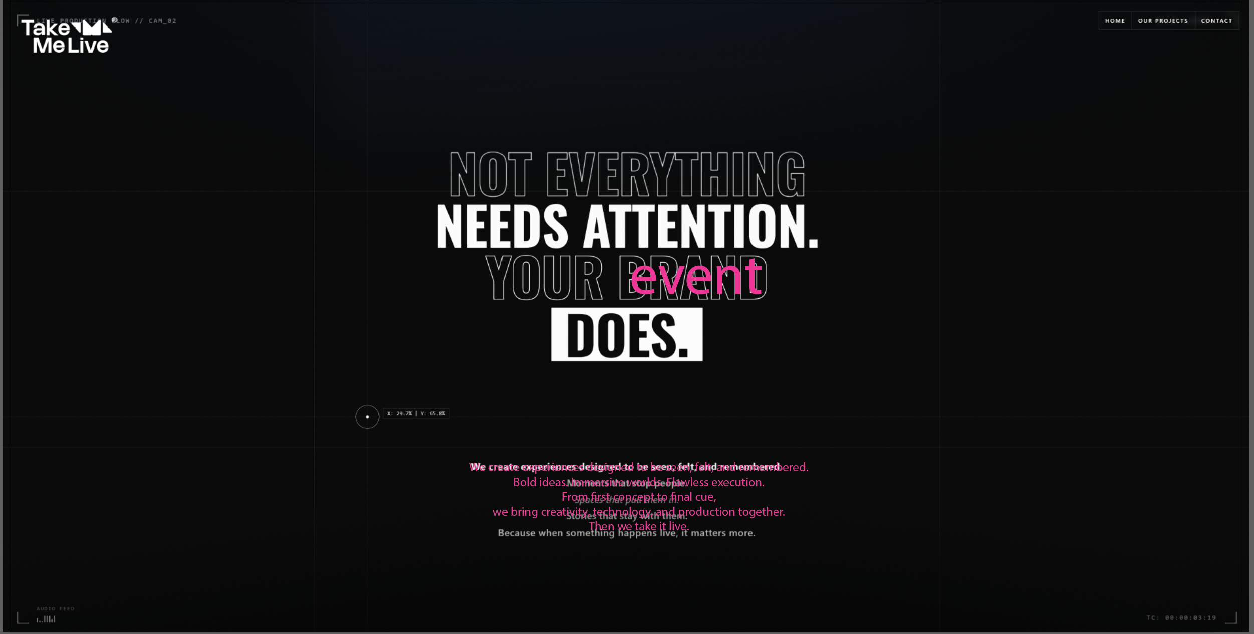

We create experiences designed to be seen, felt, and remembered.
Bold ideas. Immersive worlds. Flawless execution.
From first concept to final cue,
we bring creativity, technology, and production together.
Then we take it live.

(also the bottom right audio feed thing, either add a background music subtle one, or just get rid of the audio feed animation)

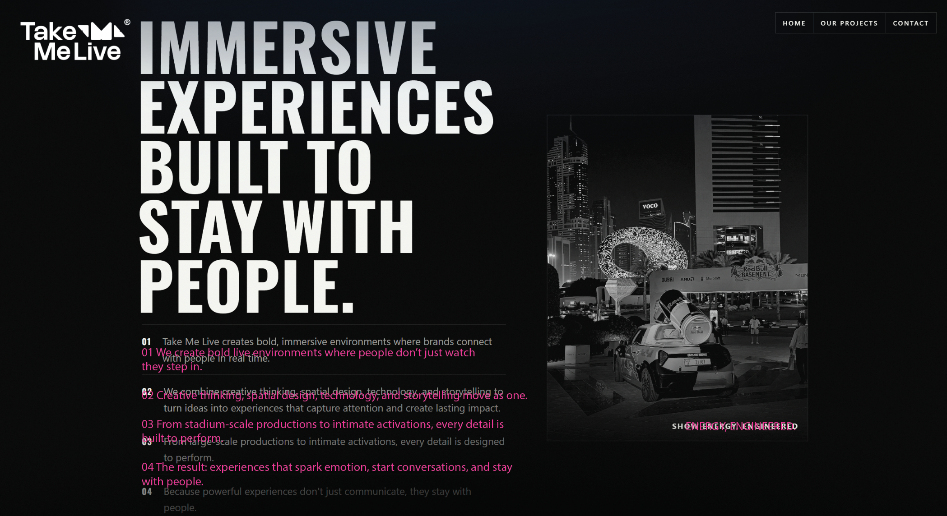

01
We create bold live environments where people don’t just watch—they step in.
02
Creative thinking, spatial design, technology, and storytelling move as one.
03
From stadium-scale productions to intimate activations, every detail is built to perform.
04
The result: experiences that spark emotion, start conversations, and stay with people.

ENERGY, ENGINEERED.

(also change the picture form black and white to color, bring back its color, and I think the numbers 01 02 03 04 give them our blue color, the blue color which we used.(check if it looks good if it doesn’t then let it be))

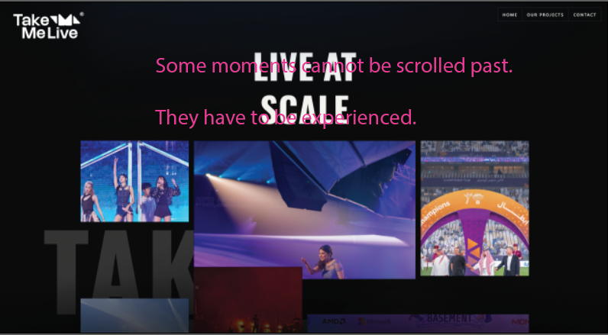
Some moments cannot be scrolled past. They have to be experienced.

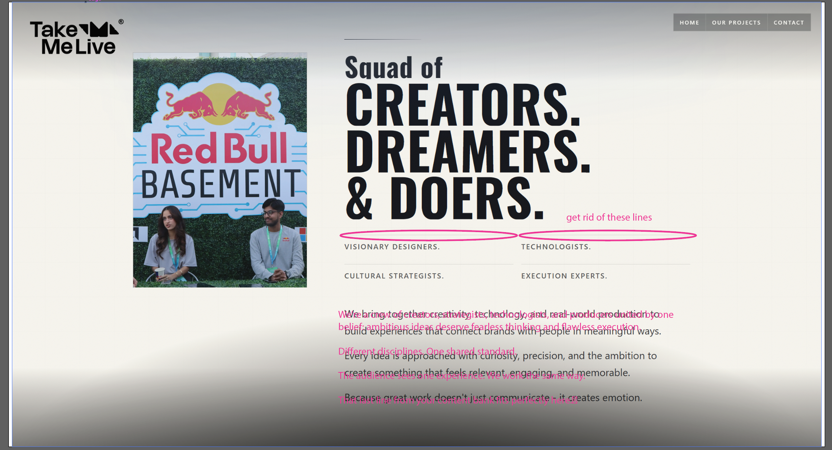

We’re a crew of creators, strategists, technologists, and producers united by one belief: ambitious ideas deserve fearless thinking and flawless execution.
Different disciplines. One shared standard.
The audience sees one experience. We work the same way.

(also gotta change the photo)

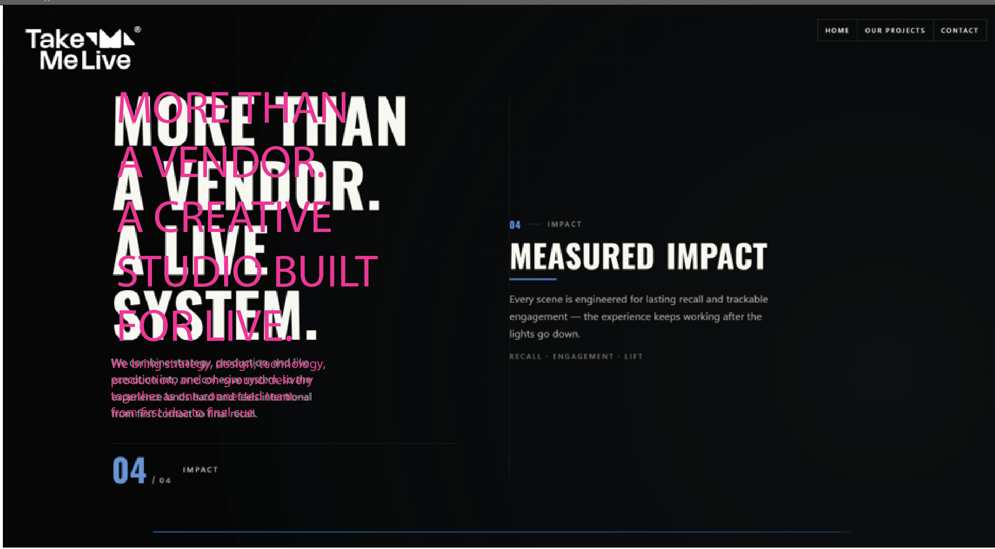

MORE THAN
A VENDOR.
A CREATIVE STUDIO
BUILT FOR LIVE.
Underneath:
We bring strategy, design, technology, production, and on-ground delivery together as one connected team—from first idea to final cue.

01 — Creative Strategy
Change CONCEPTING to CREATIVE STRATEGY.
CULTURE-LED CONCEPTS
We begin with the audience, the context, and the reason the moment exists—then build the idea around them.
Every decision is shaped to feel relevant, culturally aware, and true to the people in the room.
AUDIENCE · CONTEXT · INTENT

02 — Execution
ONE TEAM. FULL EXECUTION.
Creative, technical, production, and on-ground delivery move as one.
No handoffs, no lost intent, and no gap between what was imagined and what finally goes live.
STRATEGY · BUILD · SHOW CALL
03 — Technology
TECHNOLOGY THAT SERVES THE STORY.
We use technology to deepen participation, amplify emotion, and make the experience feel more alive.
From AI to interactive systems and show control, every tool earns its place by serving the story.
INTERACTIVE · AI · SHOW CONTROL
04 — Impact
BUILT TO BE REMEMBERED.
Every touchpoint is designed to create attention, engagement, and lasting recall—long after the lights go down.
The goal is not just to make an impression in the moment, but to create something people continue to talk about.
ATTENTION · ENGAGEMENT · RECALL
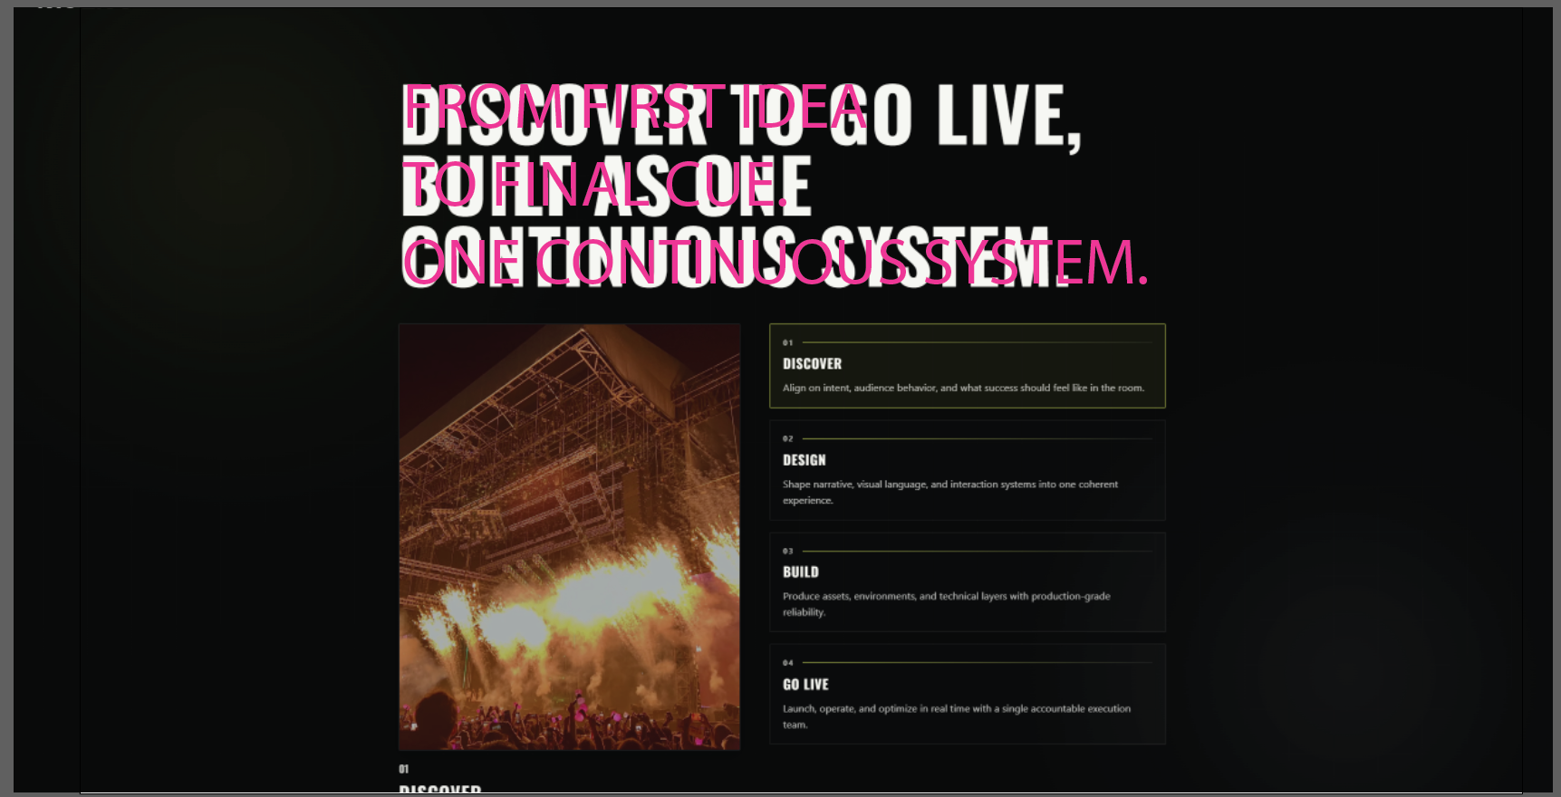

01 — DISCOVER
We align on the objective, the audience, the context, and what success should feel like in the room.
Every strong experience begins with a clear reason to exist.
02 — DESIGN
We shape the narrative, spatial journey, visual language, and interactions into one coherent world.
Every detail is designed around how people move, engage, and remember.
03 — ENGINEER & BUILD
Creative meets technical planning as we produce the environments, content, and systems that bring the idea to life.
Everything is tested for safety, reliability, and show-ready precision.
04 — GO LIVE
We rehearse, operate, and adapt in real time through one accountable delivery team.
From doors open to final cue, we keep every moving part aligned and protect the experience.

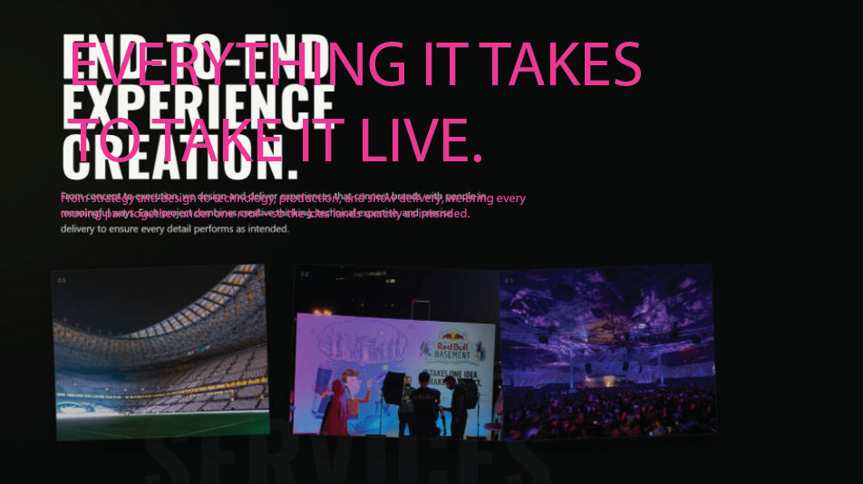
EVERYTHING IT TAKES
TO TAKE IT LIVE.
Underneath:
From strategy and design to technology, production, and show delivery, we bring every moving part together under one roof—so the idea lands exactly as intended.

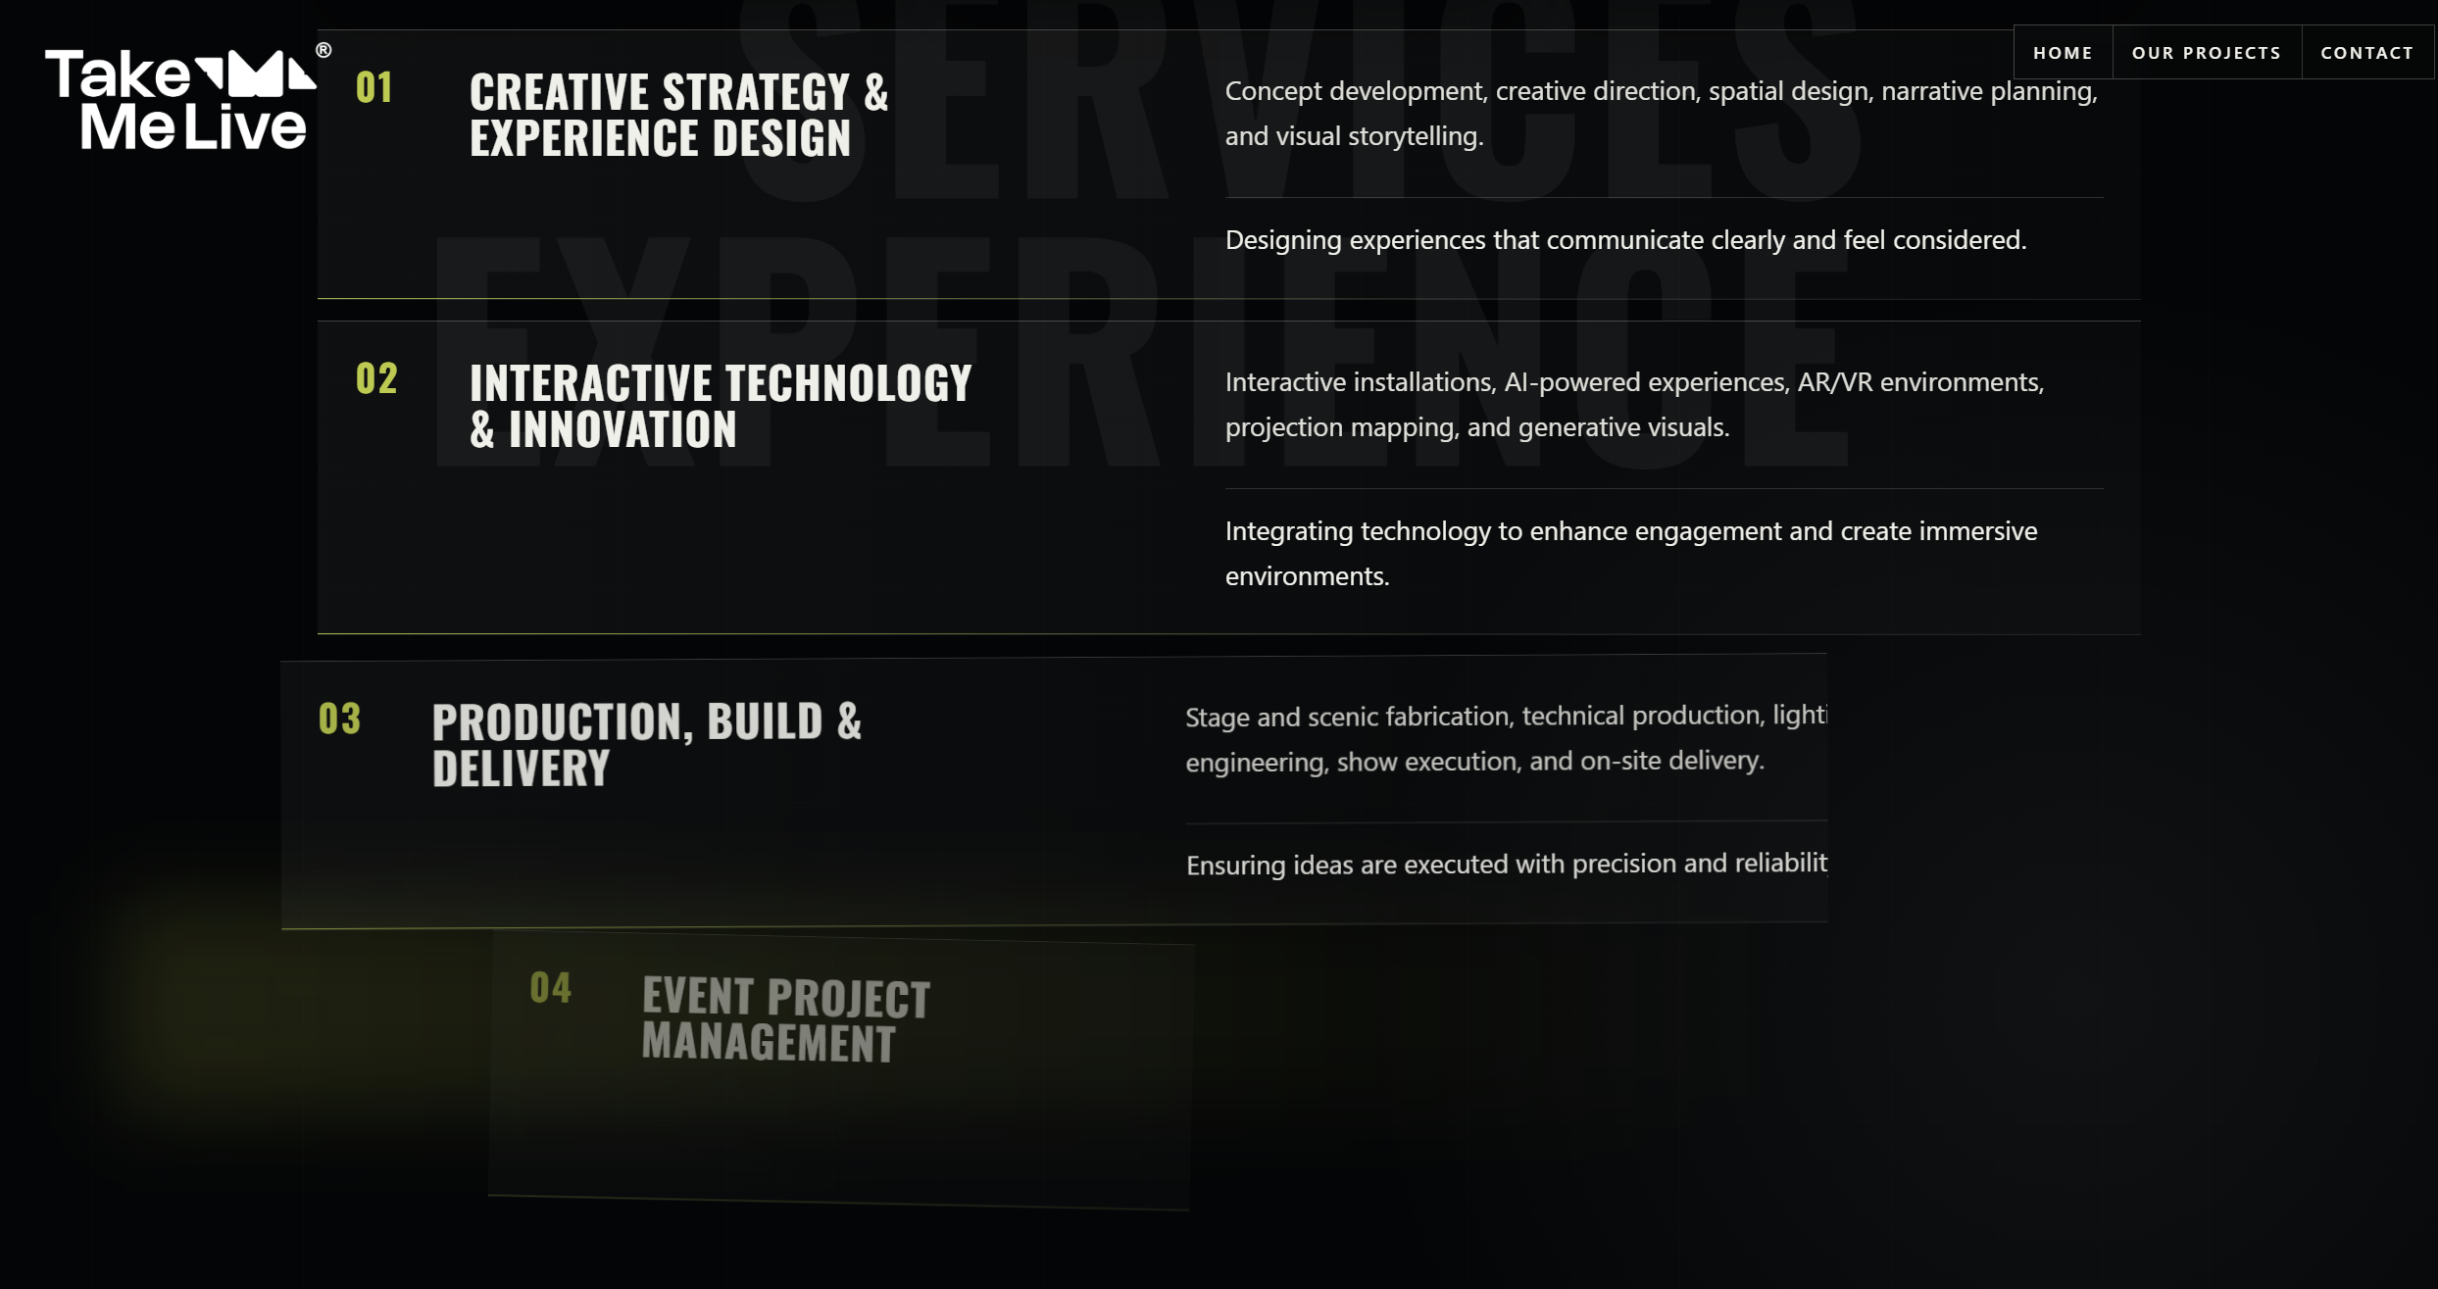

01 — CREATIVE STRATEGY & EXPERIENCE DESIGN
We shape the central idea, audience journey, spatial environment, and visual language from the ground up.
Every creative decision is built around what people should feel, do, and remember.
02 — INTERACTIVE TECHNOLOGY & INNOVATION
We integrate AI, AR/VR, projection mapping, generative content, and responsive systems into the experience.
Technology is used with purpose—to deepen participation, not distract from the story.
03 — PRODUCTION, BUILD & DELIVERY
We engineer, fabricate, install, test, and operate every production layer with show-ready precision.
From scenic build to lighting, sound, video, and live execution, we keep the original idea intact all the way to site.
04 — EVENT PROJECT MANAGEMENT
We manage timelines, budgets, vendors, permits, crews, logistics, and on-site operations from start to finish.
One accountable team keeps every moving part aligned and every decision visible.
05 — DIGITAL AMPLIFICATION & CONTENT
We create screen content, live streams, social moments, event films, and post-event assets that extend the experience beyond the room.
The live moment becomes the beginning of a longer story—not the end of it.

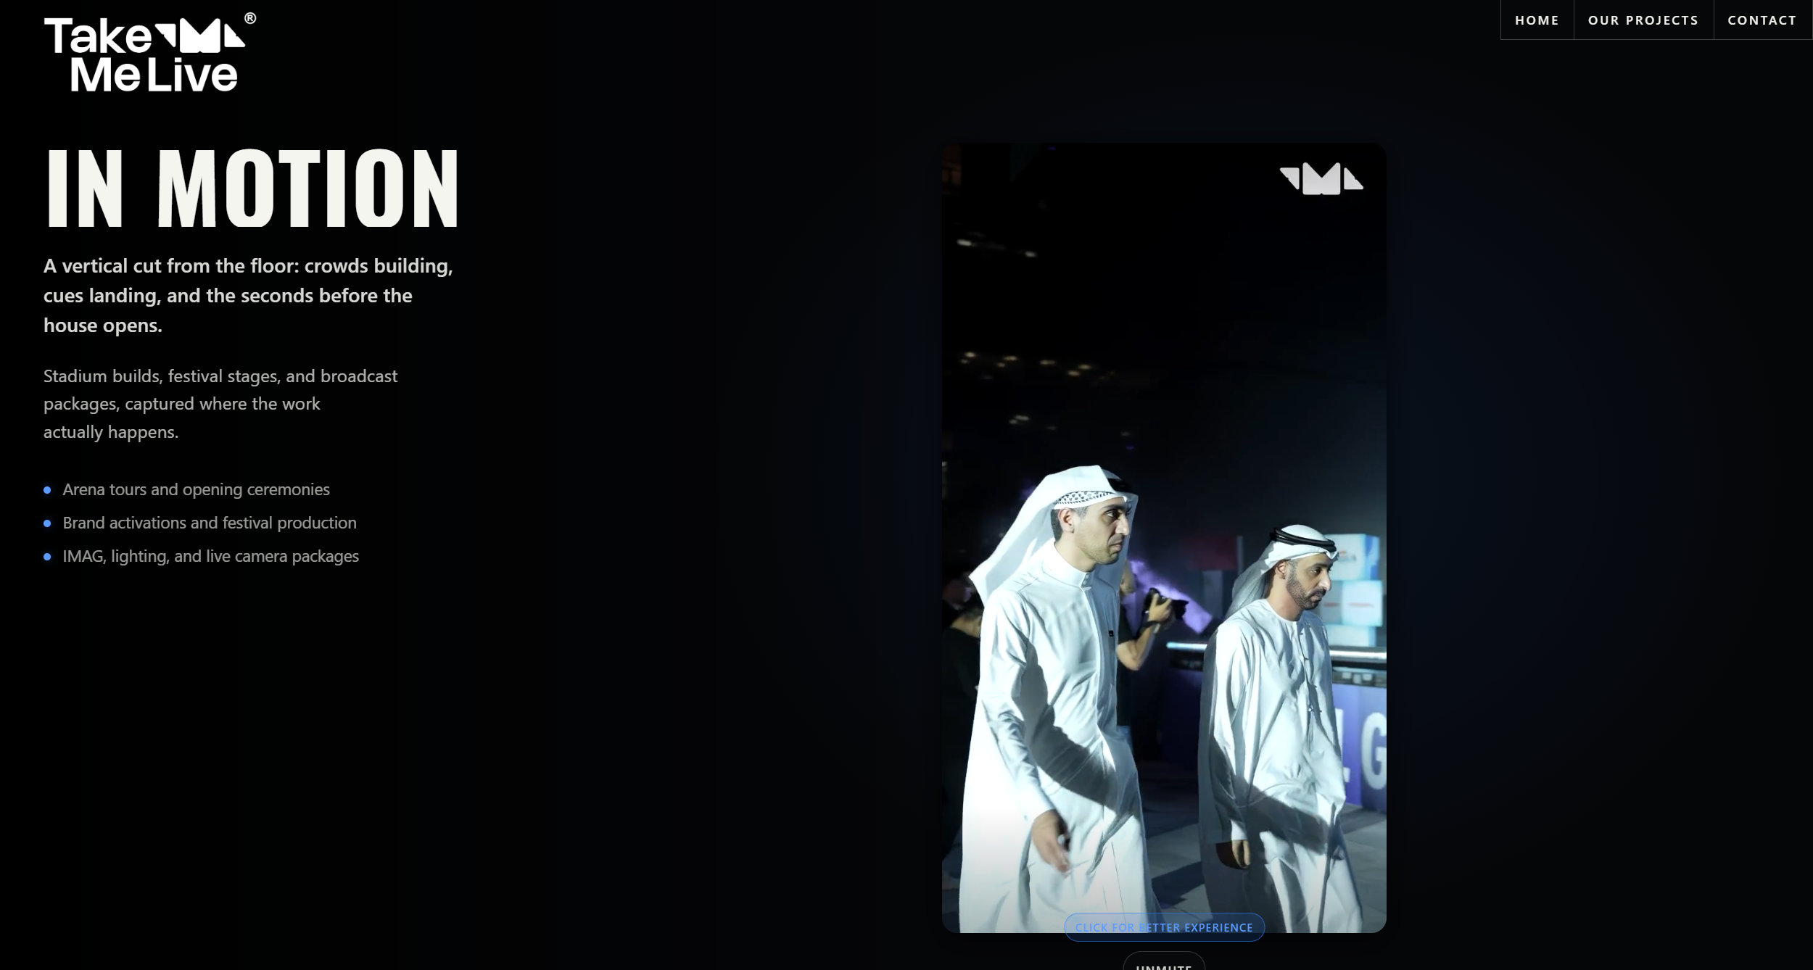

IN MOTION
The live moment starts long before the audience arrives.
On site, every build, cue, camera, and crew member moves together—turning plans into a show-ready reality.
From stadium productions to brand activations and live broadcasts, this is where the work comes alive.
- Stadium and arena productions
- Brand activations and festival builds
- IMAG, live cameras, lighting, and show systems

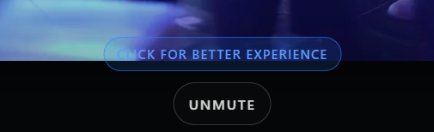
Move the click fort better experience button above.
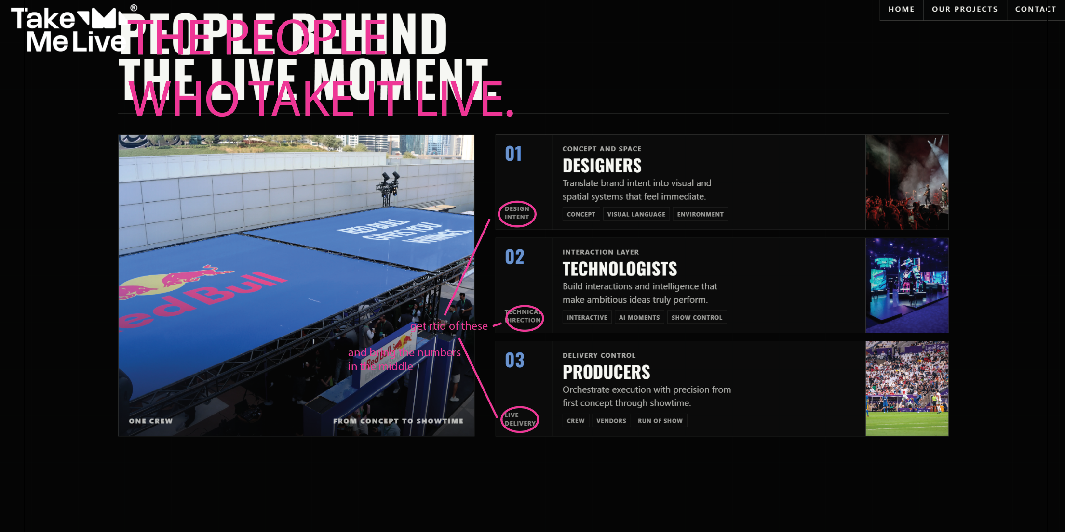
THE PEOPLE
WHO TAKE IT LIVE.
01 — DESIGNERS
CONCEPT & SPACE
Turn strategy into visual worlds, spatial journeys, and experiences people feel from the moment they enter.
CONCEPT · SPATIAL DESIGN · SHOW DESIGN
02 — TECHNOLOGISTS
INTERACTION & SYSTEMS
Build interactive technology, intelligent content, and show-control systems that make ambitious ideas perform seamlessly.
INTERACTIVE · AI/XR · SHOW CONTROL
03 — PRODUCERS
PRODUCTION & DELIVERY
Connect every crew, vendor, timeline, and cue—protecting the original idea from first briefing to final show call.
CREW · LOGISTICS · RUN OF SHOW

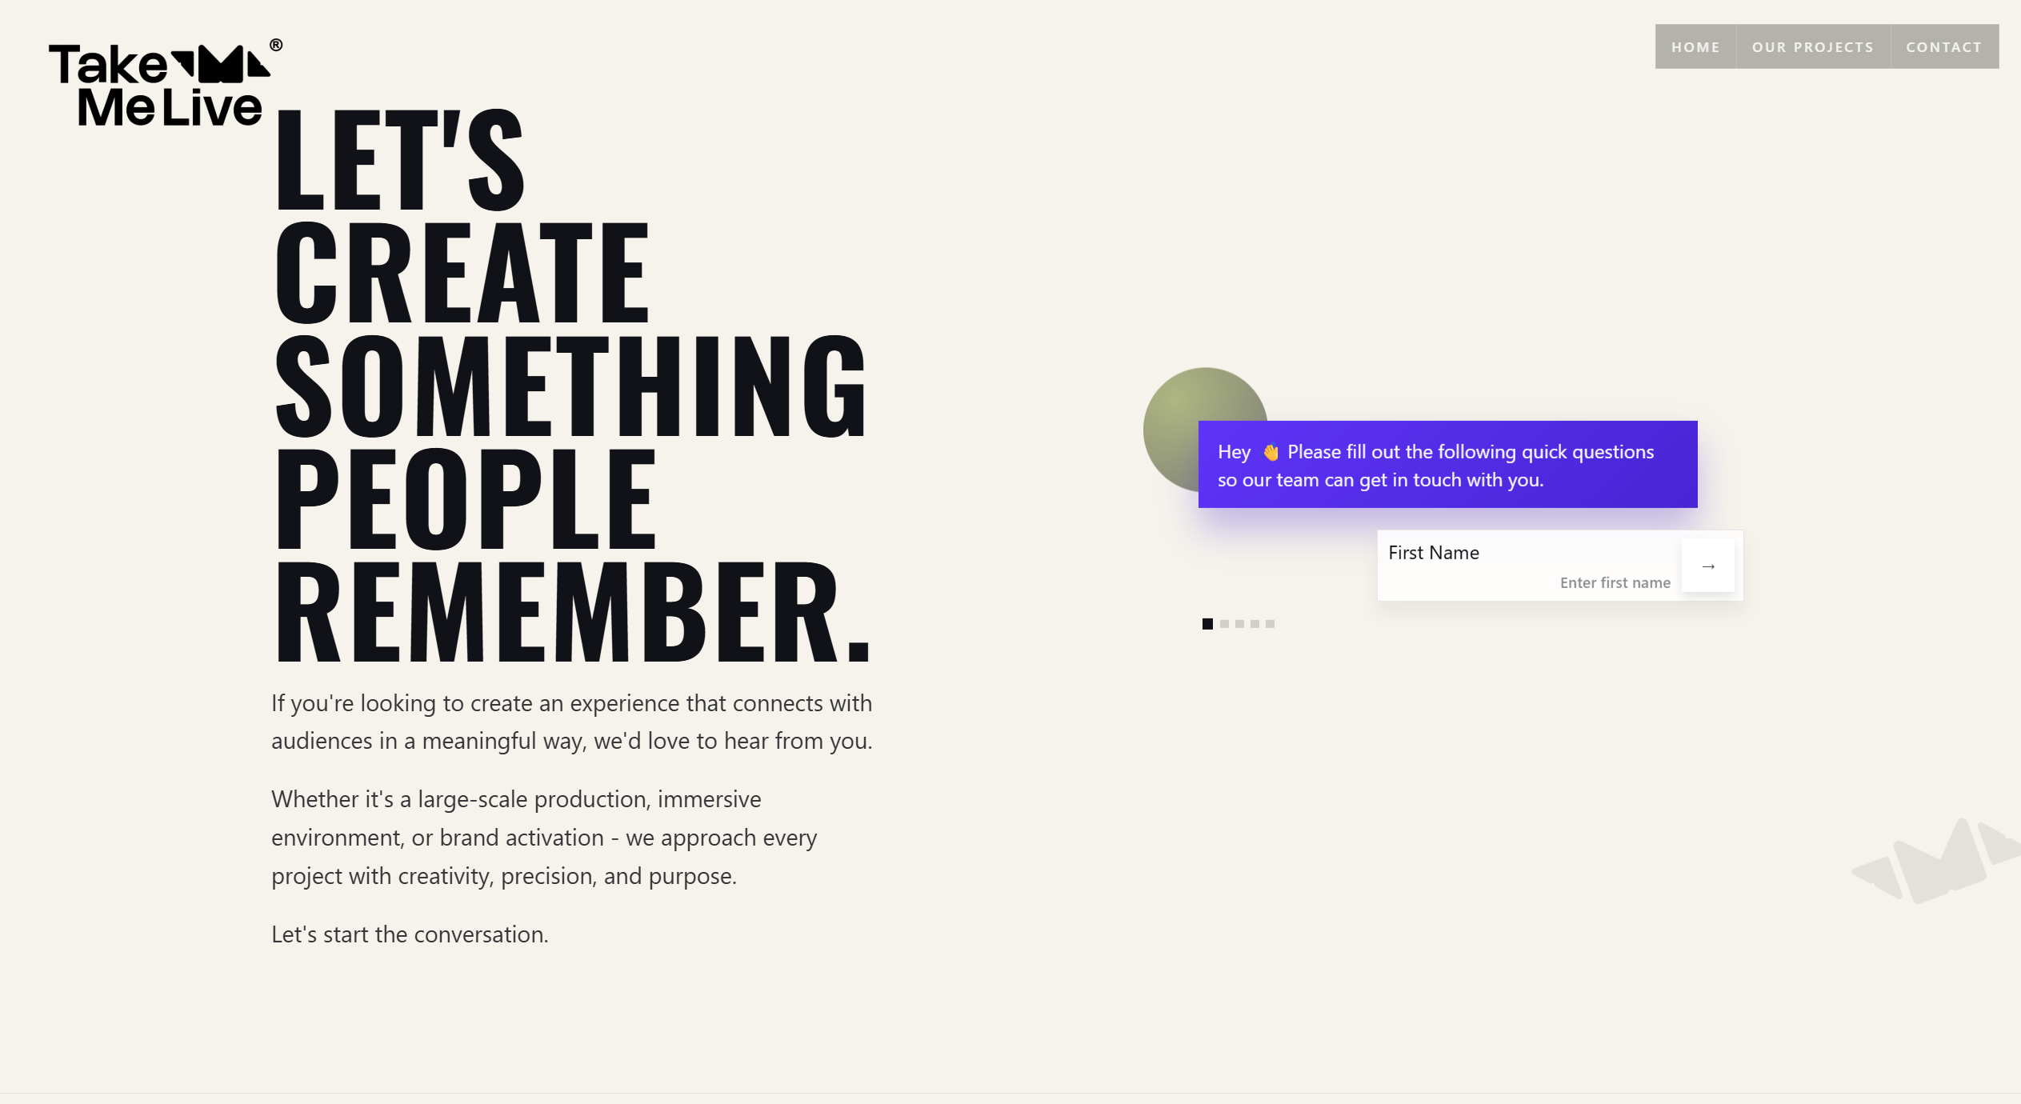

LET’S CREATE
SOMETHING
PEOPLE
REMEMBER.

Have an idea that needs to happen live?
Bring us the ambition, the challenge, or the beginning of an idea.
From immersive environments and brand activations to large-scale live productions, we bring creativity, technology, and execution together to make it real.
Let’s take it live.

For the form message, change it to:
Tell us what you’re planning.
Answer a few quick questions and our team will get back to you.
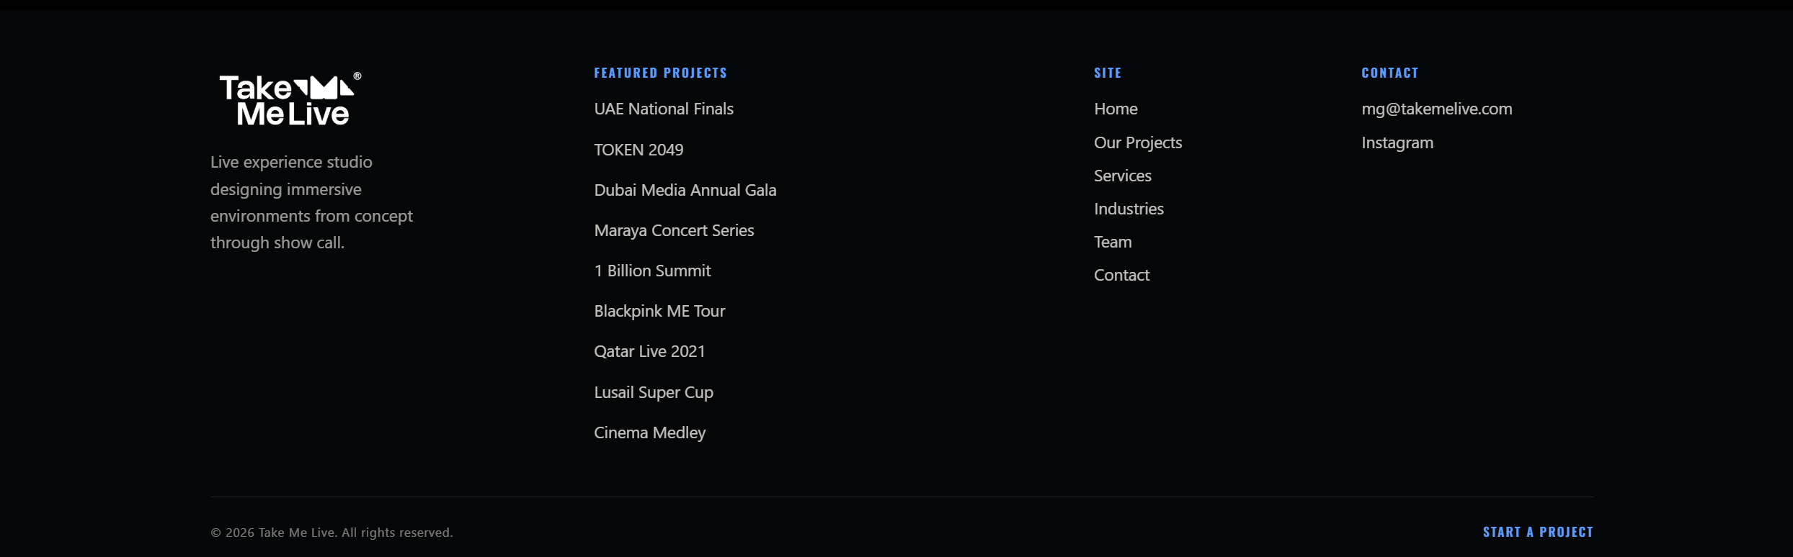
Creative experience studio turning ambitious ideas into live productions, immersive environments, and brand experiences—from concept to final cue.

Site links
HOME
OUR PROJECTS
CONTACT
hello@takemelive.com

Instagram
LinkedIn

Dubai · Riyadh · Los Angeles

Change:
UAE NATIONAL FINALS
To:
RED BULL BASEMENT
UAE NATIONAL FINALS
Subtitle:
An innovation environment built for pitching, content, and connection.
Project information
CLIENT
Red Bull
LOCATION
DIFC Gate Village, Dubai, UAE
DATE
April 2026
SCOPE
Project Management · Scenic & Production Design · Custom Build · Technical Production · Experience Zones · Site Delivery
Keep the complete technical service list elsewhere or inside an expandable Full Scope section. It is currently difficult to scan.
Replace “Concept” and “Story” with this
THE BRIEF
Create a complete live environment for entrepreneurs, creators, judges, and guests—supporting pitching, demonstrations, content creation, networking, and audience engagement.
OUR RESPONSE
Take Me Live managed the project from production planning through on-site delivery.
We designed and built the branded entrance, media wall, main stage, judges’ platform, demo gallery, podcast area, and the technical infrastructure connecting every experience zone.
Audio, lighting, video, LED, power, scaffolding, furniture, permits, manpower, setup, and dismantling were coordinated through one accountable production team.
THE EXPERIENCE
Guests moved through a layered journey of arrival, presentations, product demonstrations, interviews, content, and networking—while every space remained connected to the Red Bull Basement identity.
THE RESULT
A polished, high-energy national finals platform designed to spotlight the UAE’s next generation of innovators.
Layout recommendation
Use The Brief and Our Response in the first two columns. Place The Experience and The Result beneath them as shorter blocks. This will reduce the wall of text and make Take Me Live’s actual contribution immediately clear.
Also add a bold line before the image gallery:
INNOVATION, BROUGHT INTO THE ROOM.
TOKEN 2049
Change the subtitle to:
A technology brand translated into light, data, and motion.
That line belongs here—it describes the project immediately without repeating the title.
Project information
CLIENT
io.net
LOCATIONS
Madinat Jumeirah, Dubai — TOKEN2049
Singapore — SuperAI
DATE
April & June 2024
SCOPE
Experience Design · Exhibition & Lounge Design · Art Direction · Technical Design · LED Content · Production & Delivery
Keep the capitalization as io.net, TOKEN2049, and SuperAI consistently across the site.
Replace “Concept” and “Story”
THE BRIEF
Create exhibition and networking environments that expressed the speed, scale, and future-facing nature of io.net’s technology across two major international events.
OUR RESPONSE
Working alongside Phoenix, Take Me Live developed a minimal cyberpunk environment where LED became the primary architectural, lighting, and storytelling language.
Towering digital monoliths carried custom visuals, futuristic interfaces, live countdowns, and real-time information—transforming the space through light, movement, and data.
THE EXPERIENCE
Visitors entered a living digital world rather than a conventional exhibition stand.
Neon cityscapes, responsive content, and immersive visual systems created a distinctive environment for meetings, networking, and brand discovery.
THE RESULT
A bold visual identity delivered consistently across Dubai and Singapore, reinforcing io.net’s position as a future-focused technology brand.
Gallery headline
Before the project images, use:
THE FUTURE, MADE PHYSICAL.

DUBAI MEDIA
ANNUAL GALA
Subtitle:
A corporate celebration transformed through interaction, entertainment, and technology.
Project information
CLIENT
Dubai Media
LOCATION
Grand Hyatt, Dubai
DATE
February 2024
SCOPE
Creative Direction · Scenic & Production Design · LED Stage · Interactive Experiences · Content Creation · Technical Production · Live Delivery
Replace “Concept” and “Story”
THE BRIEF
Create an annual gala that celebrated Dubai Media’s people, creativity, and culture through a more interactive and engaging guest experience.
The challenge: deliver the complete production within only four days.
OUR RESPONSE
Take Me Live created a bold LED-led environment supported by personalised digital welcomes, interactive photo experiences, LED flooring, custom raffle content, live entertainment, and an employee art gallery.
Every element—from guest arrival to stage content and VIP operations—was coordinated as one continuous experience.
THE EXPERIENCE
Guests were welcomed by name through QR-connected LED screens before entering a space filled with technology, performance, and participation.
Live musicians, artists, digital activations, and personalised moments kept the evening moving and gave guests more than one way to engage.
THE RESULT
A visually distinctive, guest-focused production delivered within an exceptionally compressed timeline—bringing Dubai Media’s commitment to creativity and innovation to life.
Gallery headline
FOUR DAYS.
ONE COMPLETE
TRANSFORMATION.

MARAYA
CONCERT SERIES
Subtitle:
One iconic venue. Twenty-eight distinct visual worlds.
Project information
CLIENT
Live Nation Middle East
LOCATION
AlUla, Saudi Arabia
DATE
September 2022 – March 2023
SCOPE
Show Production · Visual Content · Lighting Design · Stage Treatments · Technical Delivery
Replace “Concept” and “Story”
THE BRIEF
Produce a major concert series inside Maraya, one of AlUla’s most iconic venues.
Each performance needed its own visual identity while respecting the architecture, cultural setting, and character of the artist.
OUR RESPONSE
Take Me Live developed tailored lighting, visual content, stage treatments, and 90-minute visual journeys for every show.
The creative approach changed with each artist—moving from intimate and minimal to powerful and cinematic—while preserving the integrity of Maraya’s mirrored architecture.
THE EXPERIENCE
Audiences entered a different world at every performance.
International stars and regional icons were presented through visual environments shaped around their music, identity, and the spirit of AlUla.
THE IMPACT
Twenty-eight shows featuring artists including Andrea Bocelli, Mariah Carey, John Legend, Usher, Mohammed Abdo, Kadim Al Sahir, Assala Nasri, and Angham.
The series reached 2.8 million viewers globally, while hosting an intimate live audience of approximately 400 guests per evening.
Gallery headline
ONE VENUE.
A NEW WORLD
EVERY NIGHT.

Title
RED BULL
ENERGY LOUNGE
Subtitle:
A multi-zone brand world built for energy, content, and connection.
Project information
CLIENT
Red Bull
LOCATION
Jumeirah Emirates Towers, Dubai, UAE
DATE
January 2026
SCOPE
Experience Design · Exhibition & Lounge Design · Art Direction · Technical Design · Custom Build · Interactive Integration · Live Delivery
Replace “Concept” and “Story”
THE BRIEF
Create a Red Bull destination within the fast-moving environment of the 1 Billion Summit—one that could support networking, hospitality, content creation, entertainment, and interaction throughout the day.
OUR RESPONSE
Take Me Live designed and delivered a layered environment anchored by a central Red Bull hospitality bar.
The space brought together a DJ zone, F1 simulators, a live-streaming room, a dedicated podcast platform, networking areas, and more intimate basement-inspired spaces.
THE EXPERIENCE
Visitors could compete, create content, join live conversations, meet collaborators, or step away from the energy of the summit without ever leaving the Red Bull world.
Every zone offered a different reason to engage, while the full environment remained visually and operationally connected.
THE RESULT
A flexible, high-energy destination that supported continuous programming across the three-day summit and kept visitors returning throughout the event.
Gallery headline
ENERGY, BUILT
INTO EVERY ZONE.

BLACKPINK
MIDDLE EAST TOUR
Subtitle:
A stadium-scale production delivered across two cities.
Project information
CLIENT
Live Nation Middle East
LOCATIONS
Riyadh, Saudi Arabia · Abu Dhabi, UAE
DATE
January 2023
SCOPE
Technical Production · Vendor Management · LED · Lighting · Lasers · Special Effects · iMAG · Live Delivery
Replace “Concept” and “Story”
THE BRIEF
Deliver the local technical production for BLACKPINK’s Middle Eastern tour dates in Riyadh and Abu Dhabi, working to the precision and scale of a major international touring show.
OUR RESPONSE
Take Me Live led local vendor and technical coordination across both cities, integrating six automated LED screens, 500 lighting fixtures, 40 lasers, and 100 special-effects units.
We also supported an 18-camera iMAG system, large-format side screens, and a synchronised pyrotechnic finale developed with the touring team.
THE EXPERIENCE
A high-intensity live spectacle combining choreography, large-scale visuals, lighting, live cameras, flames, CO₂, lasers, and pyrotechnics.
Every system worked together to carry the show’s energy across the full venue.
THE IMPACT
Two technically complex productions delivered for more than 70,000 fans, with every local department aligned to the standards of a global arena tour.
Gallery headline
GLOBAL TOUR.
LOCAL EXECUTION.
ZERO COMPROMISE.

Title
QATAR LIVE 2021
Subtitle:
A convention centre transformed into an immersive live arena.
Project information
CLIENT
Live Nation Middle East
LOCATION
Doha, Qatar
DATE
December 2021
SCOPE
Experiential Production · Technical Engineering · Projection Mapping · Content · Scenic Build · Live Delivery
Replace “Concept” and “Story”
THE BRIEF
Transform the Doha Exhibition and Convention Center into a major cultural and entertainment destination during the Arab Cup.
The environment needed to combine architecture, technology, content, and performance at an unprecedented scale.
OUR RESPONSE
Take Me Live served as the execution partner for the complete venue transformation, delivered over twenty days.
At its centre was The Flower—a projection-mapped structure built from 92 petals and suspended through 482 rigging points. To overcome the venue’s structural limitations, our team engineered a bespoke ground-support system.
THE EXPERIENCE
Guests moved through customised entrances, branded lobbies, photo environments, and a fully immersive concert arena.
Every element worked as part of one visual journey, turning the venue into a living environment for 17,500 guests.
THE IMPACT
A 5.5-million-square-foot venue transformed into a large-scale cultural spectacle, setting a new benchmark for experiential production in the region.
Gallery headline
20 DAYS.
92 PETALS.
ONE LIVING SPECTACLE.

Title
LUSAIL
SUPER CUP
Subtitle:
A stadium debut told through culture, light, music, and collective energy.
Project information
CLIENT
FIFA & Supreme Committee for Delivery & Legacy
LOCATION
Lusail Stadium, Doha, Qatar
DATE
September 2022
SCOPE
Stadium-Scale Production · Stage Engineering · Lighting · Audience Technology · Pyrotechnics · Broadcast Coordination · Live Delivery
Replace “Concept” and “Story”
THE BRIEF
Help launch Lusail Stadium through a major pre-World Cup moment that brought football, entertainment, and regional culture together.
The production needed to reflect the stadium’s architecture and Arab visual heritage while performing at global broadcast scale.
OUR RESPONSE
Take Me Live engineered key production elements across the stadium, including the circular performance stage, stadium-wide lighting, audience technology, camera blocking, and pyrotechnic coordination.
Every cue was precision-timed around Amr Diab’s headline performance and the live broadcast.
THE EXPERIENCE
The stadium became one connected visual environment through lighting, music, fireworks, content, and 80,000 synchronised LED wristbands.
More than a football match, the night became a shared cultural spectacle for the entire audience.
THE IMPACT
A defining launch moment delivered for 77,575 spectators, featuring 500 lighting fixtures, 3,500 fireworks, and one fully synchronised stadium-scale show.
The production set a powerful benchmark ahead of the FIFA World Cup Qatar 2022.
Gallery headline
77,575 PEOPLE.
ONE STADIUM.
ONE SHARED MOMENT.

Title
CINEMA MEDLEY
Subtitle:
Film music transformed into a live visual and symphonic experience.
Project information
CLIENT
Imperial Orchestra
LOCATION
Coca-Cola Arena, Dubai
DATE
May & December 2024
SCOPE
Stage Design · Technical Production · Lighting · Audio · Visual Content · Live Delivery
Replace “Concept” and “Story”
THE BRIEF
Bring Imperial Orchestra’s Middle East debut to life through a production that matched the scale, emotion, and cinematic power of its programme.
The stage needed to support a full orchestra, choir, specialist instruments, and large-format visual storytelling.
OUR RESPONSE
Take Me Live delivered the stage and technical production across two performances—Cinema Medley in May and the larger Cinema Medley 2 in December.
Lighting, audio, visual content, and stagecraft were designed to move in perfect sync with the orchestra and give every soundtrack its own atmosphere.
THE EXPERIENCE
Audiences experienced iconic film scores through a blend of live music, cinematic imagery, and immersive lighting.
The December production brought together 120 musicians, including orchestra, choir, and folk instruments, performing music from Oppenheimer, The Lord of the Rings, Titanic, James Bond, and more.
THE IMPACT
Cinema Medley 2 included the premiere of the Oppenheimer symphonic suite and established Imperial Orchestra’s presence in the Middle East through a technically precise, emotionally powerful arena production.
Gallery headline
THE SOUNDTRACK
BECAME
THE SPECTACLE.

